Republic of the Philippines

Western Mindanao State University

**College of Computing Studies**

DEPARTMENT OF COMPUTER SCIENCE

Zamboanga City

**TOMATO IS LIFE: SMART SORTING SOLUTION**

**FOR QUALITY TOMATOES**

A Thesis Presented to the Faculty of

Department of Computer Science

College of Computing Studies

In Partial Fulfillment of the Requirements for the Degree of

Bachelor of Science in Computer Science

**CHARL’S BENEDICK MARTELL W. INOFERIO**

**RHEAJENN D. SALA**

**MARY HAROLHETTE O. ROM**

Researchers

**MR. JAYDEE C. BALLAHO, MIT**

Adviser

May 2025

Republic of the Philippines

Western Mindanao State University

**College of Computing Studies**

DEPARTMENT OF COMPUTER SCIENCE

Zamboanga City

# Approval Sheet

The Thesis attached hereto, entitled **“Tomato Is Life: Smart Sorting Solution for Quality Tomatoes”**, prepared and submitted by **Rhea Jenn D. Sala, Charl’s Benedick Martell W. Inoferio, and Mary Harolhette O. Rom**, in partial fulfillment of the requirements for the degree of Bachelor of Science in Computer Science, is hereby **recommended for Oral Examination**.

**MR. JAYDEE C. BALLAHO, MIT**

Adviser

**APPROVED** by the Oral Examination Committee on **_______________** with a rating of **PASSED**.

**<PANEL 1>**

Chairperson

**<PANEL 2>**

Member

**<PANEL 3>**

Member

**Accepted** in partial fulfillment of the requirements for the degree of **Bachelor of Science in Computer Science**

**MS. LUCY FELIX-SADIWA, MSCS**

Head, Department of Computer Science

**RODERICK P. GO, Ph.D.**

Dean, College of Computing Studies

# Acknowledgment

This section recognizes the persons and organizations who assisted the proponents in the completion of the thesis. Acknowledgments should be expressed simply and tactfully.

# Abstract

This is a presentation of the thesis summary. Included in the thesis abstract is the statement of the problem, objective/s of the study, methodology, major findings, significance, and conclusions. The abstract should not be less than 200 words but not exceed 500 words and must be in single line. Normally the abstract does not include any reference to the literature.

**Keywords:** <provide at least 3 keywords, separated by a comma, which could be obtained from the research paper itself>

# Table of Contents

Approval Sheet i

Acknowledgment ii

Abstract iii

Table of Contents iv

List of Figures vi

List of Tables vii

List of Appendices viii

CHAPTER I INTRODUCTION 1

Background of the Study 1

Statement of the Problem 1

Objectives 2

Scope and Limitations 3

Significance of the Study 3

Definition of Terms 5

CHAPTER II REVIEW OF RELATED LITERATURE 7

Related Studies 7

Synthesis 12

Conceptual Framework 15

Theoretical Framework 15

CHAPTER III METHODOLOGY 17

Research Design 17

Respondents 17

Data Gathering Instruments, Techniques, and Procedures 18

Statistical Tools 19

Analytical Tools 20

Technical Tools 21

Software Process Model 27

System Architecture 29

Deployment and Testing 30

CHAPTER IV RESULTS AND DISCUSSION 32

CHAPTER V CONCLUSION AND RECOMMENDATIONS 33

Conclusion 33

Recommendations 33

References 35

# List of Figures

Figure 1: Conceptual Framework 19

Figure 2: Analytical Tools 25

Figure 3: Software Process Model 34

Figure 4: System Architecture 36

# List of Tables

Table 1: Definition of Terms 6

Table 2: Comparison Based on Materials 14

Table 3: Comparison Based on Features 16

Table 4: Tomato Properties 22

Table 5: Distribution of Tomatoes 22

Table 6: Hardware Components 27

Table 7: Project Costing 32

Table 8: Software Components 33

# List of Appendices

Appendix A: Gantt Chart 38

Appendix B: Survey Form 40

Appendix C: User Interface 44

Appendix D: Test Cases 48

Appendix E: Evaluation Tool 51

Appendix F: Relevant Source Code 53

Appendix G: User Manual 54

Appendix H: Plagiarism Report 55

Appendix I: Research Critique and Editing Certificate 56

Appendix J: Curriculum Vitae 57

# CHAPTER I INTRODUCTION

## Background of the Study

Tomato (Solanum Lycopersicon) is a widely cultivated fruit crop in the Philippines due to its versatility in culinary applications and high nutritional value. It is a warm-season crop that can be grown in a wide range of soil types and climatic conditions [1]. Philippines is considered as an agricultural country due to its tropical weather and non-damaging climate. Farming has been the main job of Filipinos especially crop farming where land is used for growing of fruit, vegetable and grain. Farmers have many kinds of works and it is all through the human effort and a lot time was needed to accomplish all the chores [2].

Tomatoes emerge as one of the most profitable crops both locally and globally, driven by its market demand and profitability. Yet, ensuring the delivery of high-quality tomato products has become essential in meeting consumer satisfaction and sustaining market competitiveness. It will not only enhance the reputation of producers but also boost sales and customer loyalty [3]. Despite its profitability, the tomato industry struggles with challenges in sorting processes, leading to inefficiencies and wastage. And with the increase in consumers, the agricultural sector experiences a rise in demand.

Currently, manual sorting methods dominate the process harvesting, however, it comes with disadvantages such as high labor costs, work fatigue, inconsistency, and low accuracy [4]. Moreover, relying on human judgment for the sorting process can introduce inconsistencies and errors in the process [5]. Hence, these shortcomings highlight the urgent need for innovative technological interventions to enhance the efficiency and precision of tomato sorting. With the assistance of modern-day technology and advancements in Artificial Intelligence, such as computer vision, a better solution may be developed for producing high-quality tomatoes, sorting must be efficient and precise.

Therefore, this study aims to develop a smart sorting solution by combining IoT technologies that can analyze tomatoes objectively based on color, size, and if the tomato is of bad quality. By connecting traditional sorting approaches with smart technology, this study aims to address these challenges in the sorting process.

## Statement of the Problem

Farmers work hard to always provide customers with high-quality products that satisfy their needs for tasty, visually appealing fruits and vegetables. However, the emergence of bad tomatoes presents an issue from farm to market. Farmers face factors such as pests, diseases, and weather conditions, which contribute to low-quality tomatoes, affecting not only economic loss but also production. Moreover, the presence of bad tomatoes threatens to weaken consumer trust, thus highlighting the need for an approach to ensure that only the high-quality tomatoes reach the market.

To address this problem, sorting process must be done efficiently, accurately, and cost-effectively. Yet because sorting process mostly relies on people working by hand, it takes a lot of hard work and time. Furthermore, it is prone to human error, which might lead to causing mistakes when sorting. Besides, manual sorting is held back by how fast and how long humans can work [6].

Therefore, this study aims to develop a smart sorting solution by combining IoT technologies that will help reduce the need for people to sort manually and make sorting faster. This includes sorting by identifying if tomato is bad, categorizing by size (small and large), and lastly, sort tomatoes by color (green and red). This solution aims to enhance the sorting process efficiency, ultimately guaranteeing that only the high-quality and finest tomatoes are selected for distribution. In addition, it not only benefits farmers by reducing manual labor and cost and improving product quality but also enhances customer satisfaction.

## Objectives

The general objective of this study is to develop an IoT-enabled tomato segregation system consisting of cameras/sensors to capture tomato images and transmit data for segregation. Specifically, the study will:

* Gather and preprocess a dataset of tomato images, ensuring representation of various colors, bad, and size encountered in tomato production.
* Implement image processing algorithms for color, bad, and size detection using computer vision techniques to accurately identify, categorize, and count the numbers of tomatoes real- time.
* Integrate hardware such as conveyor belt, camera, sensor, servo motors, and Arduino as components to build the IoT-enabled sorting model.
* Evaluate the effectiveness of the IoT-enabled sorting model by measuring segregation accuracy, time to complete the sorting, and assess feedback.

## Scope and Limitations

This research primarily focuses on features designed to organize the sorting process and optimize efficiency. This system is equipped with a high-resolution camera and advanced image processing algorithm that can accurately detect and count the numbers of tomato with the predetermined criteria which are color (green and red), size (small and large), and bad tomatoes. Using this data, the system offers a wide range of classification ensuring that only the top-quality tomatoes reach the customers. Additionally, with smart tomato solution, provides real-time scenarios and customization that can meet the requirements of the market demand. It also utilizes an ultrasonic sensor integrated with LED as an indicator for monitoring container capacity, alerting farmers and letting them monitor the tomatoes effortlessly. With the system's ability to handle large volumes of tomatoes rapidly and accurately, it poses a great impact and contribution to the agricultural environment and the food supply chain.

## Significance of the Study

This study is focused on effectively and accurately sort tomatoes based on color, size, and bad tomato. The development of the study will be beneficial to the following:

**Local farmers.** The result of this study will help farmers ensure consistent quality of tomato produce. Additionally, it helps in reducing labor costs and time spent on manual sorting, therefore increasing productivity. Furthermore, through accurately sorting tomatoes based on predefined criteria, farmers can deliver high-quality products.

**Customers.** The result of this study will help ensure that customers receive tomatoes of consistent quality, meeting their expectations for freshness and appearance. Also enhancing customer satisfaction and trust in the product.

**Agricultural sector.** The result of this study signifies a larger movement towards the incorporation of automation and technology within agriculture. Through the utilization of these advancements, the agricultural industry stands to enhance its efficiency, productivity, and sustainability. Furthermore, such enhancements hold promising potential for strengthening food security, fostering economic growth, and promoting environmental preservation.

**Food waste management.** The result of this study can help reduce food waste at various stages of the supply chain. By ensuring that only marketable tomatoes are distributed for sale, less produce ends up being discarded due to spoilage or visual imperfections. This contributes to more sustainable food production and consumption practices.

## 

## Definition of Terms

Table 1: Definition of Terms

| **Term** | **Definition** |
| --- | --- |
| 1. Sliding Door | A sliding door consists of one fixed panel attached to two hangers on rollers which slide along a track. The panel slides back and forth to create a door opening [7]. |
| 1. ESP 32 CAM | A great for many smart IoT tasks like wireless video watching, uploading images over Wi-Fi, identifying QR codes, and more. It's perfect for things like uploading images from smart home devices and wireless surveillance [8]. |
| 1. Pathway | A path, route, or way to go [9]. |
| 1. Funnel | A cone-shaped tool with a small tube at the top to pour liquid or other stuff into a bottle, jug, or similar container [10]. |
| 1. Conveyor Belt | A conveyor belt is a looped belt that is driven by and wrapped around one or more pulleys [11]. |
| 1. Sorting | A way of organizing things that uses a link field in each record [12]. |
| 1. Servo Motor | A tool that can move things in circles or straight lines very accurately in machines [13]. |
| 1. Ultrasonic Sensor | A tool that figures out how far away something is by sending out special sound waves [14]. |
| 1. Breadboard | A foundation for making semi-permanent models of electronic circuits [15]. |
| 1. Container | A hollow thing like a box or bottle used to carry or store stuff [16]. |
| 1. Arduino | An open-source tool that helps users to create interactive electronic objects [17]. |
| 1. LED | A semiconductor device that shines light when electricity passes through it [18]. |
| 1. Image processing | A process of changing a picture into a digital version and doing things to it to get helpful details [19]. |
| 1. Machine Learning | A part of computer science that's about teaching computers to learn from data and get better at tasks over time [20]. |
| 1. Wires | Are bits of metal that carry electricity [21]. |

# CHAPTER II REVIEW OF RELATED LITERATURE

## Related Studies

## Technology in Sorting Tomato

Agriculture has been essential for human survival throughout history, and it remains the backbone of many nations’ economies. As the world continues to change and advance technologically, agricultural practices are being used in even more industries and areas of study [22].

Zuo [2022] analyzes the use of image processing and machine vision technologies in tomato quality sorting. According to the author, these technologies play a vital role in transforming tomato sorting systems. He stated the importance of these technologies in helping sort tomatoes quickly and accurately, making the process better. Automating the sorting process can lessen the burden of people working manually and ensure consistent and reliable results in the sorting process. Even though the advancements in technology are important, the author sees some difficulties with using image processing and machine vision technologies for sorting tomatoes. These include needing algorithms that can handle different conditions, as well as needing better hardware for processing things quickly. In addition, the author recognized chances for more innovation, such as using advanced sensor technologies and deep learning algorithms to make sorting more accurate and faster [23].

Arakeri et al. [2016] developed a tomato sorting system using computer vision. The authors used image processing techniques to check the fruit for defects and ripeness. The study consists of two parts: a hardware setup for image capturing and fruit handling, and a software program for analyzing the fruit images. The hardware equipment consists of a conveyor belt system, a camera, and control mechanisms based on a microcontroller. In the study, image processing methods were applied to sort tomatoes, extract features, and classify them using a neural network. The result of the study showed positivity, achieving a 96.47% accuracy rate in assessing the tomato quality [24].

Sari et al. [2022] introduced a tomato sorting method focused on color, size, and weight. The authors applied image processing and sensor technology. The detection of color was executed using the HSV color model, while size measurement was executed by finding the inner points of detected objects and using a load cell sensor for weight. The study was developed using a conveyor, servo motors, an Arduino Uno microcontroller, and a webcam to capture images. The findings showed perfect accuracy in color detection and 95% accuracy in weight detection. However, measurements of dimensions only showed 5% accuracy, highlighting the need for further improvement [25].

Behera et al. [2019] innovated an automated system for tomatoes both in classification and grading with the use of image processing techniques. They utilize an approach of a machine vision system comprising of digital camera and MATLAB software for image processing. The process encompassed tomato image capture, grayscale conversion, thresholding, and lastly, removing parameters. As a result, tomatoes were categorized into small, medium, and large sizes, while varieties such as cherry, classic, and cylindrical were also identified. For validation of the study, a total of 300 tests were performed across various types of tomatoes, achieving a high accuracy result in both classification and grading. Furthermore, cross-validation with ground truth measurements, through the use of Vernier caliper, yielded an outcome of correlation coefficients (R2) of 0.98 for length and 0.97 for width, indicating the system's reliability [26].

Abekoon et al. [2024] conducted a study focused on predicting tomato quality by using image processing techniques. Tomatoes were subjected to image capture, and Convolutional Neural Networks (CNNs) were applied for analysis. The study included the development of two CNN models: one for the binary classification of tomatoes and another for multi-class classification covering various maturity stages. Activation functions were employed for classification purposes. The findings of the study showcased a high accuracy in classifying tomatoes based on maturity stages post-harvest duration time. Model 1 attained 99% accuracy in both training and validation, whereas Model 2 achieved 99% and 98% accuracy in training and validation, respectively. Furthermore, the study presented consistent durations for tomatoes in different maturity stages post-harvest, with tomatoes in the red stage showing the longest duration [27].

Patil et al. [2022] introduce the idea of automating tomato quality identification using image processing methods. It consists of several processes, this process includes the following: sample collection, image capturing, pre-processing, sorting, and lastly classification. The Data sample of tomatoes will be collected from local markets for the process of sample collection, then followed by high-standard quality imagery for the analysis. Pre-processing techniques will also be used to improve machine vision to capture high-standard images and erase unwanted interference thus resulting in accurate sorting. In addition, in detecting rotten or rejected tomatoes as well as tomato separation that varies from their respective color types, the process of spot detection and K-means will be utilized in the sorting methods of the study. Lastly, for the classification techniques, Support Vector Machine (SVM) and Artificial Neural Network (ANN), are used to categorize and specify tomatoes as fresh or rotten. The study focuses on the potential of image processing through the use of machine supervision in the agricultural technology category. However, the results in comparison of classification techniques provide further recommendations on potential opportunities for further research that would best enhance the notion of the study [28].

Girma et al. [2023] proposed a study in the year 2023 regarding automated tomato sorting using computer vision. This study focuses on classifying tomatoes based on their quality (freshness, size, and overall aspects). Using Artificial Neural Network (ANN) classification which helps focus on the texture, size, and color features which were collected from the estimated number of 180 captured images of tomatoes in three different regions. The researcher/s the technique MATLAB for image processing to gather and analyze features into data and perform the necessary classification for segregation. This process includes the following methods which are image capturing, sorting based on color brightness, and feature extraction that analyzes the shape, size, and color traits of the tomatoes. After several conducts and testing the study finally provided a conclusive outcome of segregation and the characteristics extraction of tomato images which came as successful and provided precise classification that correlates to the set criteria. An ANN-based classification model was also used within the development of this study, with input neurons that represent the tomato’s shape, size, and color characteristics which were extracted and gathered from tomato images. The model was trained on a subset of the dataset and proven using individual samples, displaying high classification accuracy for tomatoes for each region. Thus, this concludes that the use of image processing through machine vision in agricultural quality identification displays various potential beneficiaries for improving and enhancing market competitiveness and increased agricultural productivity [29].

Tee et al. [2022] propose the topic of a tomato grading system with the help of a computer vision application for the enhancement of both efficiency and accuracy within the agricultural sector. The author of this study focuses on in-depth learning, especially on the notion of Convolutional Neural Networks (CNNs) that regard image classification. From the several statements of the authors, CNNs rise on the part in identifying complex patterns, making them suitable and sufficient for tasks like defect detection. They also used a surface defect detection model based on CNNs in their study. Using transfer learning, their model reprocesses pre-trained architectures, thus improving the model to classify tomatoes based on their surface defects (rotten or swollen parts). The results showed their model an accuracy of 97.61%, showing the model's reliability and sophistication in analyzing defect detection. In addition, their study also includes a size measurement algorithm using the OpenCV application. The authors elaborate on the image processing process, along with edge detection and contour analysis, Euclidean distance was also included for the computation of tomato sizes. Their results for the accuracy algorithm show the Root-Mean-Square-Error (RMSE) of 0.258 mm and high agreement indices with its efficacy in size measurement [30].

Dorado et al. [2016] suggested developing a system that automatically sorts and grades tomatoes by quality and ripeness levels using image processing and fuzzy logic. The study involved using both hardware and software parts, including machine vision systems and fuzzy logic algorithms, in the MATLAB program. The study concluded that applying fuzzy logic could improve how tomatoes are sorted in farming. In addition, further research and development are needed to make the system more accurate and scalable, so it can be widely used in farming [31].

Yong et al. [2019] proposed a study aimed at assessing the quality of tomatoes. The authors used a method of sorting based on color, employing MATLAB along with K-Means Clustering and Pixel Area Subtraction. The study explains the functional analysis, hardware and software planning, and testing methods. It describes how the prototype was developed, including the conveyor belt, cameras, lightbox, and the image processing techniques applied using MATLAB. The study tested how well the system could detect accurately, organize, cover different areas, and do tasks quickly. The results showed that the system could detect damage 90.00% accurately and sort tomatoes 83.33% correctly. Furthermore, the tomato detection area increased to 95.24%, showing progress [32].

## Synthesis

Table : Comparison Based on Materials

|  |  |  |  |  |  |  |
| --- | --- | --- | --- | --- | --- | --- |
| **Materials** | **“Computer Vision Based Fruit Grading System for Quality Evaluation of Tomato in Agriculture Industry”** | **“The Use of Image Processing and Sensor in Tomato Sorting Machine by Color, Size, and Weight”** | **“Classification & Grading of Tomatoes using Image Processing Techniques”** | **“Smart Farm: Automated Classifying and Grading System of Tomatoes using Fuzzy Logic”** | **“Tomato Quality Identifier Applying Color-Based Segmentation Using MATLAB with K-Means Clustering and Pixel Area Subtraction.”** | **Proposed Study** |
| 1. Arduino |  | **🗸** |  | **🗸** |  | **🗸** |
| 2. Sensors |  |  |  |  |  | **🗸** |
| 3. Camera | **🗸** | **🗸** | **🗸** | **🗸** | **🗸** | **🗸** |
| 4. Conveyor | **🗸** | **🗸** |  | **🗸** | **🗸** |  |
| 5.Servo Motor | **🗸** | **🗸** |  | |  | **🗸** |
| 6. LED Lights |  |  |  | |  | **🗸** |

The first study, titled “Computer Vision Based Fruit Grading System for Quality Evaluation of Tomato in Agriculture Industry,” utilized a conveyor belt system, a camera, and control mechanisms based on a microcontroller as hardware equipment for the tomato sorting system to assess the quality of tomatoes [Arakeri et al., 2016].

In contrast, the second study, titled “The Use of Image Processing and Sensor in Tomato Sorting Machine by Color, Size, and Weight,” was developed using a conveyor, servo motors, an Arduino Uno microcontroller, and a webcam to capture images and sort tomatoes, focusing on color, size, and weight [Sari et al., 2022].

The next study, titled “Classification & Grading of Tomatoes using Image Processing Techniques,” employed a camera as the main hardware for categorizing tomatoes into small, medium, and large sizes, while varieties such as cherry, classic, and cylindrical were also identified [Behera et al., 2019].

Similarly, the fourth study, titled “Smart Farm: Automated Classifying and Grading System of Tomatoes using Fuzzy Logic,” utilized Arduino, a camera, and a conveyor to sort and grade tomatoes by quality and ripeness level, along with algorithms [Dorado et al., 2016].

The fifth study, titled “Tomato Quality Identifier Applying Color-Based Segmentation Using MATLAB with K-Means Clustering and Pixel Area Subtraction,” employed a conveyor belt, cameras, and a lightbox as hardware for assessing the quality of tomatoes, along with some software [Yong et al., 2019]. Ultimately, our proposed study, titled “Tomato Is Life: Smart Sorting Solution for Quality Tomatoes,” utilizes hardware such as Arduino, sensors, a camera, a conveyor, servo motors, and LED lights for assessing tomatoes in terms of color, ripeness, and size.

Table : Comparison Based on Features

|  |  |  |  |  |  |  |
| --- | --- | --- | --- | --- | --- | --- |
| **Features** | **“Computer Vision Based Fruit Grading System for Quality Evaluation of Tomato in Agriculture Industry”** | **“The Use of Image Processing and Sensor in Tomato Sorting Machine by Color, Size, and Weight”** | **“Classification & Grading of Tomatoes using Image Processing Techniques”** | **“Smart Farm: Automated Classifying and Grading System of Tomatoes using Fuzzy Logic”** | **“Tomato Quality Identifier Applying Color-Based Segmentation Using MATLAB with K-Means Clustering and Pixel Area Subtraction.”** | **Proposed Study** |
| 1. Size Sorting |  | **🗸** | **🗸** |  |  | **🗸** |
| 2. Image Processing Algorithm | **🗸** | **🗸** | **🗸** | **🗸** | **🗸** | **🗸** |
| 3. Sensor Monitoring |  | **🗸** |  |  |  | **🗸** |
| 4. Color Sorting | **🗸** | **🗸** |  | **🗸** | **🗸** | **🗸** |
| 5. Bad Tomato Sorting | **🗸** |  |  | | **🗸** | **🗸** |
| 6. Machine Learning Algorithm |  |  |  | |  | **🗸** |

The first study, titled "Computer Vision-Based Fruit Grading System for Quality Evaluation of Tomato in Agriculture Industry," includes image processing algorithms, color sorting, checks for defects and ripeness. It makes use of neural networks to sort tomatoes, extract features, and classify them, achieving 96.47% accuracy [Arakeri et al., 2016].

The second study, titled "The Use of Image Processing and Sensors in Tomato Sorting Machine by Color, Size, and Weight", focuses on sorting tomatoes based on color, size, and weight. It utilizes image processing and sensor technology. Color detection is achieved using the HSV color model, while size measurement is based on finding the inner point of detected objects, and weight measurement utilizes load cell sensors. The study showed positive outcomes in color detection and a 95% accuracy in weight detection. However, measurements of dimensions only showed 5% accuracy, highlighting the need for further improvement [Sari et al., 2022].

The third study, titled "Classification & Grading of Tomatoes using Image Processing Techniques," innovated an automated tomato system for size and variety classification, and grading. It makes use of image processing techniques through MATLAB software and machine vision. The process includes tomato image capture, grayscale conversion, thresholding, and parameter removal. It showed positive results in both classification and grading with a total of 300 tests [Behera et al., 2019].

The fourth study, titled "Smart Farm: Automated Classifying and Grading System of Tomatoes using Fuzzy Logic," developed a system that automatically sorts and grades tomatoes by quality and ripeness levels. It also utilizes image processing algorithms, MATLAB software, and fuzzy logic to improve tomato sorting and machine vision [Dorado et al., 2016].

The fifth study, titled "Tomato Quality Identifier Applying Color-Based Segmentation Using MATLAB with K-Means Clustering and Pixel Area Subtraction," proposed a study aimed at assessing tomato quality. The authors employed a method of sorting based on color, using MATLAB along with K-Means Clustering and Pixel Area Subtraction. Through thorough testing, the system showed positive results with 90% accuracy in damage detection and 83.33% accuracy in tomato sorting. Furthermore, the tomato detection area increased to 95.24%, showing progress [Yong et al., 2019].

Ultimately, our proposed study, "Tomato Is Life: Smart Sorting Solution for Quality Tomatoes," will develop a smart tomato solution focusing on color, size, and identifying bad tomatoes. With image processing and machine learning algorithms, the study aims to yield good results in terms of accuracy and efficiency.

## Conceptual Framework

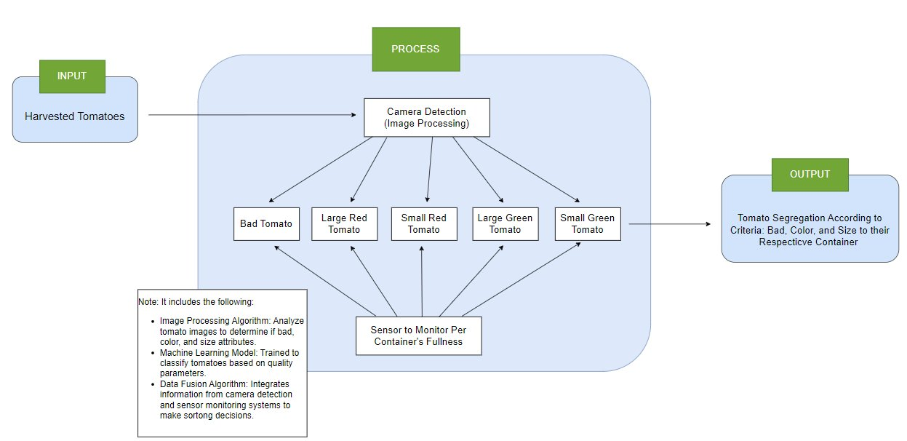

Figure : Conceptual Framework

The researchers plan to use harvested tomatoes as input for testing the system, categorizing them into three main groups: color (green and red), size (small and large) and bad tomato. Additionally, several aspects and factors were taken into account when designing and implementing the smart sorting solution for quality tomatoes, including the choice of hardware materials. To achieve precise and efficient sorting, enhance tomato quality, and minimize waste, the researchers emphasize the application of camera detection, sensor monitoring, and machine learning methodologies.

## Theoretical Framework

This study explores various methodologies and algorithms tailored specifically to categorize tomatoes based on predefined criteria such as size, color, and quality. A common approach involves the application of computer vision techniques combined with machine learning algorithms, where images of tomatoes are captured using installed cameras for detection. Additionally, utilizing an ultrasonic level sensor integrated with an LED indicator as an approach to efficiently manage the filling process of containers.

The data is processed to determine the level of tomatoes within the container and when it reaches a predetermined level, the LED system is triggered to indicate that the container is full, prompting necessary actions such as halting the process. This will serve as a blueprint that guides researchers and tomato sorting can be automated, enhancing efficiency, reducing labor costs, and improving overall quality control in the agricultural industry.

# 

# CHAPTER III METHODOLOGY

## Research Design

This study employs a quasi-experimental research design to evaluate the effectiveness of the smart tomato solution but lacks random assignment for participants. There will be no comparison between the manual sorting method and the smart tomato solution as their process is entirely different, therefore no control group. Only the experimental group which is the smart tomato solution would be assessed. It will be matched with the predefined criteria such as color (green and red), size, and bad tomatoes. The smart tomato solution significantly improves efficiency in sorting tomatoes through its automated processes and advanced algorithms. Data will be collected by the number of bad, green, and red tomatoes, sorting time, and efficiency in detecting.

## Respondents

This study is conducted at Kambal Farm, a local tomato farm in Tugbungan, Zamboanga City, Philippines. The study aims to evaluate the effectiveness of a smart tomato sorting process with local farmers as the primary testers. A total of 25 participants will be randomly selected from the farm's population to provide feedback on the system's performance through a survey given by the researchers.

## Data Gathering Instruments, Techniques, and Procedures

The study shall conduct an image data gathering of various tomato varieties through visual observation and digital recording, forming a dataset for system comparison. Data will then be sorted by their size, categorized if it’s rejected or not, and lastly, by their color (green and red). To further know more about the details of data collection, refer to Appendix B to understand more.

Researchers shall provide a survey and be given personally to the local farmers to assess their feedback regarding the smart tomato solution outlined in Appendix E. The experiment is carried out following the parameters in Tables 4 and 5. The number of tomatoes used, sorted sizes, color, and the start and end time will be recorded for comparison.

Table : Tomato Properties

|  |  |
| --- | --- |
| **Category Name** | **Description** |
| Small | Maximum Circumference (Diameter x 3.14) 18.84956 cm |
| Large | Maximum Circumference (Diameter x 3.14) 37.6991 cm |
| Red | Light red to dark red |
| Green | Green, orange, light, orange, yellow |
| Bad | Deformed, with blemishes, bad quality |

Table : Distribution of Tomatoes

|  |  |  |  |  |  |  |  |
| --- | --- | --- | --- | --- | --- | --- | --- |
| **INPUT (ACTUAL)** | | | | | | | |
| **No.** | **Tomato (pcs)** | **Size** | | **Color** | | | **Start Time** |
| *Small* | *Large* | *Red* | *Green* | *Bad* |
| 1 | 30 | 10 | 20 | 10 | 15 | 5 |  |
| 2 | 30 | 20 | 10 | 15 | 10 | 5 |  |
| 3 | 30 | 15 | 15 | 15 | 15 | 0 |  |

## Statistical Tools

The statistical tools of this study will focus on using a formula for calculating the following Accuracy, Sensitivity, Specificity, and Time.

For accuracy, the researcher shall calculate the accuracy of the model by using the percent error formula: Percent Error = (Experiment - Expected) / (Expected) x 100. This will indicate how big the errors are when it is executed. The “Experiment” in this study will be the measurements taken from the tests and the “Expected” will be the referential data that will be compared to the experiment.

The sensitivity and specificity data will be based on the TP, TN, FP, FN which are the true positives, true negatives, false positives, and false negatives. The formula to calculate the sensitivity is TP / (TP + FN) and the formula to calculate the specificity is TN / (TN + FP).

For the time computation, the researcher will categorize them by size based on the diameter of the tomatoes and time the execution to where it has been detected and sorted.

The gathered time would be taken or recorded by the performance of the machine in a sorting completion time in seconds or minute/s. the performance of the machine will vary in two categories small sizes and large sizes.

In the interpretation of the gathered data using Appendix E, this study will use a graphical scaling bar chart or pie chart. Then find the response rate using the formula RR = ((Total Attributed Conversion) / (Total Unique Users)) x 100.

## Analytical Tools

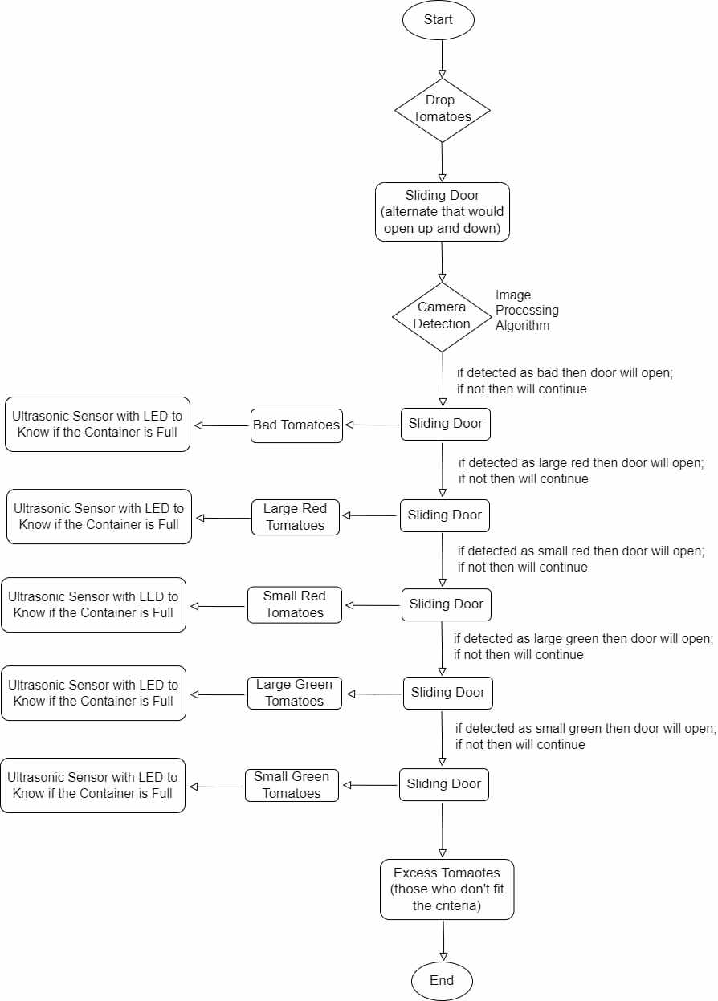

Figure : Analytical Tools

The figure above shows the overall process of the model in detail. First, the harvested tomatoes pass through a sliding door, an alternate up and down door, to ensure that only one tomato is detected at a time. With the use of camera, integrated with an image processing algorithm, it detects whether the tomato is bad, large red, small red, large green, or small green. If detected as bad, the sliding door opens, causing the tomato to fall into the bad container. If not, the tomato continues along the process. If the tomato is detected as large red, the sliding door in this section opens, directing the tomato to the large red container. If not, the tomato proceeds. Similarly, if the tomato is detected as small red, the sliding door in this section opens, guiding the tomato to the small red container. If not, the tomato continues along the process.

In the case detected as large green, the sliding door in this section opens, guiding the tomato to the large green container. If not, the tomato proceeds. Likewise, if the tomato is detected as small green, the sliding door in this section opens, directing the tomato to the small green container. If not, then the tomato falls into the excess container, which contains tomatoes that do not fit the predefined criteria. Another process is the use of an ultrasonic sensor to keep track of the container when full. If any of the containers is full, then process will halt with an LED serving as an indicator. Additionally, the researchers will also use machine learning and data fusion algorithms to make this study successful in the implementation.

## Technical Tools

This study shall utilize the use of hardware and software materials in the developing stage to fulfill and deliver the desired project in regards to its functionality and delivery. Hardware that will be utilized in the development will include the following: Servo motor, ESP 32 CAM, Arduino Uno, ultrasonic sensors, containers, plywood, stainless steel, and light bulbs LED to build our model, all are connected has its own purpose. Camera and sensors for detecting, containers where tomatoes will be place, and servo motor to help in segregation.

Additionally, researchers will also use software such as image processing algorithm to help analyze tomato images to determine color and rejected attributes, machine learning model to train and classify tomatoes based on quality parameters, and lastly data fusion algorithm to integrate the information from camera detection and sensor monitoring to make sorting decisions.

Table : Hardware Components

|  |  |  |  |
| --- | --- | --- | --- |
| Components name | image | Quantity | Purpose within the project |
| Plywood |  | 4 pcs of 4 meters | The foundation and based to where the project is being constructed |
| DC motor (gear motor optional) |  | 4pcs | Provides the motion for the conveyor |
| Arduino ESP32 CAM |  | 4 pcs | The key component of the system and how the model will detect the characteristics of the tomato using artificial machine supervision |
| Bred Board |  | 2pcs | The connections between Arduino components and the functions or command lines |
| Jumper Wire |  | 20pcs | The connections that attached the Arduino to one another |
| Servo motor |  | 6pcs | The population controller. It manages the overall capacity of tomatoes and the categorical system. |
| Power Supply motor battery |  | 1pcs | The source of power of the project |
| Nails |  | 50pcs | The key component of the project that will hold the foundation together |
| Ultrasonic Sensor |  | 6pcs | This component functions as a notification device that will notify the user if the container is full half full or not depending on the specified color |
| LED lights |  | 3pcs | The LED lights which connect to the ultrasonic sensor. This acts as a notification notice to the user. |
| Plastic container |  | 6pcs | The container where the tomato entities are being stored. |
| Arduino UNO |  | 2pcs | Arduino Uno gets data that consists of the color and size of tomatoes from the laptop. Arduino also receives data from the load cell. In addition, Arduino controls the motor according to the input |

Software Components:

In the development of the smart tomato sorting machine based on color, size, and bad tomato the researcher will utilize a C language programming for the software components. The decision to choose C language programming stems from its reputation for robustness and efficiency, particularly in the realm of hardware control for such devices. The strategy involves crafting code that interfaces with sensors responsible for color data acquisition, alongside actuators tasked with sorting tomatoes by size. Moreover, the code will incorporate algorithms to determine the sorting criteria for each tomato. By adhering to C language programming, the researcher seeks to establish a dependable and quick system capable of sorting tomatoes accurately in accordance with the predefined quality standards. However, in case of alternative options the researcher could also use the C++ language programming as an alternative programming code.

In the hopes that the project experience difficulty in the code implementation then an alternative precaution shall be in used in which the researcher shall use an alternative programming language which is python. Python is an English based programming language that can be flexible for implementation.

Table : Project Costing

|  |  |  |
| --- | --- | --- |
| Hardware Cost | | |
| ITEM | Quantity | Price in pesos |
| Plywood | 4 pcs of 4 meters | 1000.00 |
| DC motor (gear motor optional) | 4pcs | 1208.00 |
| Arduino ESP32 CAM | 4 pcs | 1000.00 |
| Bred Board | 2pcs | 160.00 |
| Jumper Wire | 20pcs | 61.00 |
| Servo motor | 6pcs | 720.00 |
| Power Supply Motor Battery | 1pcs | 308.00 |
| Nails | 50pcs | 250.00 |
| Ultrasonic Sensor | 6pcs | 240.00 |
| LED lights | 3pcs | 45.00 |
| Plastic container | 6pcs | 450.00 |
| Arduino UNO | 2pcs | 1000.00 |
| Estimated Grand Total | | 6,442.00 |

Table : Software Components

|  |  |  |
| --- | --- | --- |
| Software | | |
| Software | Cost | Purpose |
| Visual Studio Code | 0 | Provide a format for coding implementation |
| Microsoft Office | 1000 | Provide a tool for the documentation process |
| C++ Programming Language | 0 | The algorithm in which the project shall function under |
| Python Programming Language | 0 | An alternative Programming language that is an English based algorithm which can be flexible in the functionality of the system. |
| Total Costing | 1000 | |

## Software Process Model

Figure : Software Process Model

This study shall use the agile approach methodology which will conduct a step-by-step approach for developing this type of model, the smart tomato solution system. This will allow the researchers to develop their model and at the same time improve and correct upcoming errors and mishaps during implementation.

In the brainstorming phase, the researchers begin by engaging with the stakeholders involved and knowing their specific requirements. With this, both parties involved shall then be able to define the scope of the project, objectives, constraints, and limitations of the study. Additionally, generating and building ideas happen here establishing teamwork collaboration, and communication among all.

In the design phase, the researchers will gather and analyze the requirements of the project. They will determine the best approach by crafting a design specifically to meet the requirements. This may involve exploring ideas through brainstorming, creating conceptual sketches, and constructing a prototype to envision potential solutions. Following this, the system architecture will be established, and both hardware and software components shall be defined.

In the development phase, all the planning from the design phase shall be implemented. Researchers will write code based on the requirements specified in the project's design document. This process will involve translating design specifications into actual hardware and software components, modules, and features. Unit testing will also be conducted to ensure that all units work according to plan and to identify errors as early as possible to debug. Following the completion of unit testing, all components shall be integrated to test and guarantee that the system’s operation is working smoothly and functionally. Feedback is also a vital component in this phase.

In the quality assurance phase, rigorous testing will be conducted thoroughly to ensure the system’s performance. Identifying errors and debugging are the main priority in this phase. Furthermore, feedback from the participants is crucial at this stage to validate the system’s performance assuring a successful and polished deployment ready to use.

Lastly, in the deployment phase, researchers shall set an exact date for deployment in accordance with the stakeholders. Preparation must be made for both hardware and software components. Final testing shall occur at this phase. Once everything is completed, the system will be deployed.

## System Architecture

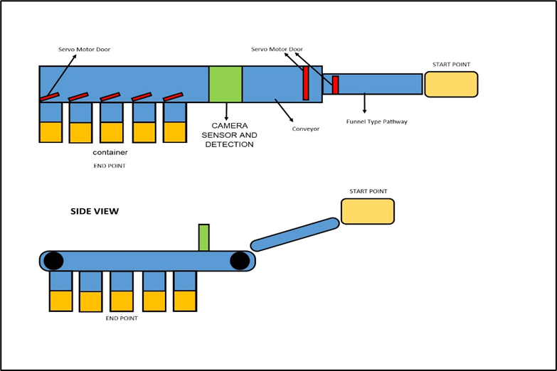

Figure : System Architecture

In the figure above, the funnel type serves as the starting point where the user inputs the harvested tomatoes, acting as an entity in this model. The funnel is slightly slanted to control the speed of the tomatoes. They will pass through the sliding door, an alternate door that moves up and down, to ensure that only one tomato is detected at a time with a camera, EMP 32 CAM, integrated with an image processing algorithm. With the conveyor belt, the tomatoes will undergo a smooth process. There are five sliding doors, with each door corresponding to its designated category and container.

After detection, the tomatoes will fall into their assigned category as the sliding door opens. Tomatoes that do not fit the predefined criteria will go into the excess container. Lastly, the containers have a level sensor function that notifies if the required maximum capacity is fully reached, which includes halting the system if any of the containers are full with LED indicator.

## Deployment and Testing

During this process, the researchers shall conduct several experimental tests (refer to Appendix D) on the primary stage-specific parts individually, such as testing for size, color, and texture, before progressing to combining these parts and conducting the initial experimental test. Before the initial deployment of the model, the researchers shall partake in tests to validate their model, and volunteers will also have the opportunity to validate and provide feedback on the model. The target participants for this study will be local farmers; however, agricultural and non-agricultural individuals may also participate in the experimentation.

The testing will be divided into two parts: component testing, where the researcher will evaluate the parts of the model individually, and model testing, where the researcher will combine all the components of the model and conduct the overall evaluation. The system shall be delivered before May 2025, with a 6-month implementation and testing phase and a 2-month debugging phase to ensure successful deployment.

Testing Activities:

* Component Testing:
  + Size sorting evaluation
    - Cylinder testing and size measurement
  + Machine vision recognition evaluation
    - Dropper testing and ESP32 Cam evaluation
  + Capacity control
    - Tomato occupancy evaluation on precision within the model
  + Level sensor detection
    - Ultrasonic sensor evaluation

# CHAPTER IV RESULTS AND DISCUSSION

* Data Collection

The dataset for the study was collected from capturing real-time images of tomatoes purchased from the market. Each tomato was captured from eight different angles to ensure comprehensive coverage. The tomatoes were categorized by color and bad, resulting in a total of 797 images collected with a 89.4% validation accuracy.

Figure : Datasets

The dataset also been classified into 3 groups (Valid, train, and test). This states the status and recommendation of Roboflow towards the datasets that where uploaded.

* Data Processing

Figure 6: Classes

This study utilized Edge Impulse, a machine learning platform for data processing and training, however, compatibility issues arose with the ESP32 Camera. As a result, the researchers switched to Roboflow, a computer vision framework. The new setup demonstrated excellent compatibility with the Raspberry Pi, which replaced the ESP32-CAM.

* Integrating Hardware

The model was built using hardware components, including servo motor, conveyor belt which uses stepper motor as its engine, and camera. The camera used was a Raspberry Pi, that was placed above the conveyor belt to capture real-time images of each tomato. A conveyor belt was utilized for transporting tomatoes continuously at a controlled speed allowing enough time for the camera to detect. Servo motor was used to guide the detected tomatoes accordingly into their designated classification.

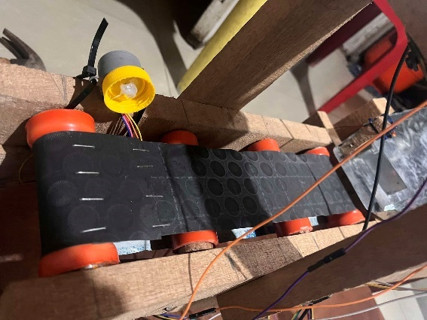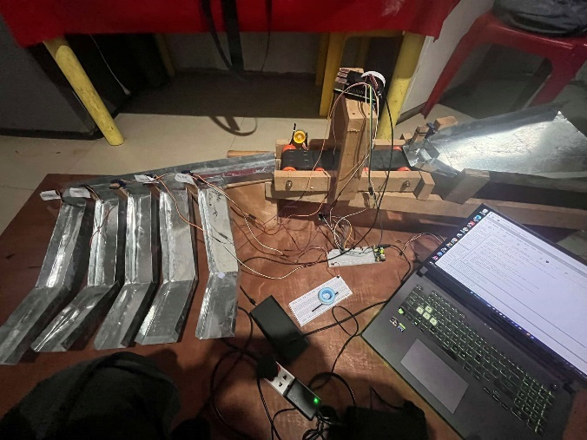

Figure 7: Model

* Effectiveness Evaluation

Due to the limited number of samples, the researchers used five tomatoes, with each tomato tested five times at different angles to evaluate the model’s effectiveness. Currently, the tomato sorter can only detect color and bad tomato, excluding size detection. The time accounts for the time the tomato was detected and the time it was sorted. So, for Tomato 1, the 4th trial recorded the fastest completion time, while the final trial failed. For Tomato 2, the 6th trial was the fastest among all conducted trials. For Tomato 3, the 14th trial showed the fastest end time, but the last trial failed to detect it. For Tomato 4, the 20th trial was the fastest, while the 4th trial failed. Finally, across all trials, the 23rd trial demonstrated the fastest completion time overall. With the results, it shows that the model has greater accuracy in color and bad detection though it still needs some improvement on its performance in Table 9. In addition to the comparison between the data accuracy of datasets trained by Roboflow it has the higher advance than the datasets trained by Edge Impulse which involves its ability to detect the assign categories (Red, Green and Bad) although the Roboflow detection is not 100% accurate.

Table : Distribution of Tomatoes

Tomato 3

Same Tomato

Tomato 2

Same Tomato

Tomato 1

Same Tomato

|  |  |  |  |  |  |
| --- | --- | --- | --- | --- | --- |
| **No.** | **Tomato (pcs)** | **Color** | | | **End Time** |
| *Red* | *Green* | *Rejected* |
| 1 | 1 |  | 1 |  | 40s |
| 2 | 1 |  | 1 |  | 15s |
| 3 | 1 |  | 1 |  | 15s |
| 4 | 1 |  | 1 |  | 13s |
| 5 | 1 |  | Error |  | No Time |
| 6 | 1 |  |  | 1 | 10s & 15s |
| 7 | 1 |  |  | 1 | 25s & 31s |
| 8 | 1 |  |  | 1 | 20s & 30s |
| 9 | 1 |  |  | 1 | 16s & 21s |
| 10 | 1 |  |  | 1 | 28s & 42 |
| 11 | 1 | 1 |  |  | 30s & 44s |
| 12 | 1 | 1 |  |  | 24s & 34s |
| 13 | 1 | 1 |  |  | 24s & 33s |
| 14 | 1 | 1 |  |  | 17s & 28s |
| 15 | 1 | Error |  |  | No Time |
| 16 | 1 | 1 |  |  | 16s & 27s |
| 17 | 1 | 1 |  |  | 17s & 42s |
| 18 | 1 | 1 |  |  | 17s & 32s |
| 19 | 1 | Error |  |  | No Time |
| 20 | 1 | 1 |  |  | 14s &16s |
| 21 | 1 |  | 1 |  | 18s & 29s |
| 22 | 1 |  | 1 |  | 18s & 30s |
| 23 | 1 |  | 1 |  | 13s & 26s |
| 24 | 1 |  | 1 |  | 28s & 41s |
| 25 | 1 |  | 1 |  | 20s & 28s |

Tomato 4

Same Tomato

Tomato 5

Same Tomato

* Problems Encountered

By executing temporary test runs we encountered several issues regarding some parts of the project. The Following are the lack of power usage, although all three servo motors who are assigned by their categorical assignments (Red, Green and Bad) are working but due to the low number of amperes provided by our current supply which provides 1 ampere only the conveyer and 2 servo motors was recorded to test properly. The recommended ampere that we researched states that a 5 or more ampere would solve the issue of the power lackage. The conveyer could also be one of the problems we encountered although when test run it tends to stuck to the side and has a delay movement thus it is still not 100% properly working.

# CHAPTER V CONCLUSION AND RECOMMENDATIONS

## Conclusion

This study successfully developed and tested a smart sorting system that classifies tomatoes by color and bad detection. The system demonstrated a solid capacity for automating the classification process, and provided real-time sorting based on predefined criteria. However, challenges such as limited sample size and compatibility issues initially constrained performance. Despite these limitations, the final model effectively employed Roboflow for image processing and Raspberry Pi hardware for integration, resulting in reliable results across most trials.

## Recommendations

Based on the study's findings, the following recommendations are suggested:

* Adding of weight sensor to improve customer satisfaction.
* Detecting foreign fruit and categorizing them into designated location to achieve its universal application.

# References

[1] Juan Magsasaka. Tomato (Kamatis) Cultivation Guide: All You Need to Know in Planting, Growing and Harvesting Tomato .

[2] Lenard C. Dorado1, Jules Ian C. Aguila, and Rionel B. Caldo. 2016. Smart Farm: Automated Classifying and Grading System of Tomatoes using Fuzzy Logic.

[3] 2024. The Benefits of Creating a Quality Product. *FasterCapital*.

[4] Omid Arjenaki, Parviz Moghaddam, and Asaad Moddares Motlagh. 2012. Online tomato sorting based on shape, maturity, size, and surface defects using machine vision.

[5] Robert G. De Luna, Elmer P. Dadios, Argel A. Bandala, and Ryan Rhay P. Vicerra. 2019. Tomato Fruit Image Dataset for Deep Transfer Learning-based Defect Detection. In *Proceedings of the IEEE 2019 9th International Conference on Cybernetics and Intelligent Systems and Robotics, Automation and Mechatronics, CIS and RAM 2019*, January 11, 2019. 356–361.

[6] Nihil Soundar. 2023. Disadvantages of manual sorting for fasteners. *Meduim* (June 2023).

[7] Sliding doors. *Build*.

[8] AI-THINKER. Camera Module Based on ESP32 with ESP32-CAM-MB adapter.

[9] 2024. pathway. *Dictionary*.

[10] 2024. funnel. *Dictionary*.

[11] Conveyor Belts. *Industrial Quick Search*.

[12] list sorting. *Encyclopedia*.

[13] 2024. Servomotor. *Wikipedia*.

[14] 2023. How Ultrasonic Sensors Work. *MasBotix*.

[15] 2024. Breadboard. *Wikipedia*.

[16] container. *Cambridge Advanced Learner’s Dictionary & Thesaurus*.

[17] 2024. Arduino. *Wikipedia*.

[18] 2024. Light-emitting diode. *Wikipedia*.

[19] 2023. What Is Image Processing : Overview, Applications, Benefits, and More. *Simplilearn*.

[20] What is machine learning (ML)? . *IBM*.

[21] Wire. *Energy Education*.

[22] 2021. The Importance of the Agriculture Industry. *Associated Equipment Distributors (AED)*.

[23] Haichun Zuo. 2022. Analysis and Detection of Tomatoes Quality using Machine Learning Algorithm and Image Processing. (September 2022).

[24] Megha P. Arakeri and Lakshmana. 2016. Computer Vision Based Fruit Grading System for Quality  Evaluation of Tomato in Agriculture industry  .

[25] Marlindia Ike Sari, Rizal Fajar, Tedi Gunawan, and Rini Handayani. 2022. The Use of Image Processing and Sensor in Tomato Sorting Machine  by Color, Size, and Weight .

[26] Santi Kumari Behera, Abhijeet Mahapatra, Amiya Kumar Rath, and Prabira Kumar Sethy. 2019. Classification & Grading of Tomatoes using  Image Processing Techniques .

[27] Thilina Abekoon, Hirushan Sajindra, J A D C A Jayakody, and Rasanjali Samarakoon. 2024. Image Processing Techniques to Identify Tomato Quality under Market Conditions. *Smart Agricultural Technology* (March 2024).

[28] Kavita Patil and Manisha Gawande. 2022. Identifying the Quality of Tomatoes in Image Processing. *Int J Res Appl Sci Eng Technol* 10, 1 (January 2022), 780–782. <https://doi.org/10.22214/ijraset.2022.39909>

[29] B. GIRMA, B.S. GOSHU, and E. MENGISTU. 2023. INSPECTION OF TOMATOES USING IMAGE PROCESSING TECHNIQUES.

[30] Say Jin Tee and Abdul Rashid bin Mohamed Shariff. 2022. TOMATO GRADING SYSTEM WITH COMPUTER VISION.

[31] Lenard C. Dorado1, Jules Ian C. Aguila, and Rionel B. Caldo. 2016. Smart Farm: Automated Classifying and Grading System of Tomatoes using Fuzzy Logic.

[32] Einstein Yong, Shaun Wesley I. Lemen, Jolina G. Paz, and Patrick Vince L. Rodriguez. 2019. Tomato Quality Identifier Applying Color-Based Segmentation Using MATLAB with K-Means Clustering and Pixel Area Subtraction.

**Appendix A: Workplan**

1. **Program Title:** N/A
2. **Project Title:** TOMATO IS LIFE: SMART SORTING SOLUTIONFOR QUALITY TOMATOES
3. **Project Duration (number of months):** 12 months **(4) Project Start Date:** January 2024 **(5)** **Project End Date:** May, 2025

|  |  |  |  |  |  |  |  |
| --- | --- | --- | --- | --- | --- | --- | --- |
| **(4) OBJECTIVES** | **(7) TARGET ACTIVITIES** | **(7) TARGET**  **ACCOMPLISHMENTS** | **Y1** | | | |  |
| **Q1** | **Q2** | **Q3** | **Q4** | **Total** |
| Gather and preprocess a dataset of tomato images, ensuring representation of various colors, bad, and size encountered in tomato production. | Collect tomato images from various sources | Dataset containing diverse tomato images collected and preprocessed |  |  |  |  |  |
| Implement image processing algorithms for color, bad, and size detection using computer vision techniques to accurately identify, categorize, and count the numbers of tomatoes real- time. | Implement color detection algorithms | Algorithms developed for real-time color detection on tomato images |  |  |  |  |  |
| Implement bad tomato detection algorithms | Algorithms implemented for real-time bad tomato detection in tomato images |  |  |  |  |  |
| Implement size detection algorithms | Algorithms implemented for real-time size detection in tomato images |  |  |  |  |  |
| Integrate hardware such as conveyor belt, camera, sensor, servo motors, and Arduino as components to build the IoT-enabled sorting model. | Select and purchase necessary hardware components | Cameras, sensors, servo motor, and Arduino components selected and acquired |  |  |  |  |  |
| Design and build the sorting model | Sorting model constructed and configured for integration with the sorting model |  |  |  |  |  |
| Evaluate the effectiveness of the IoT-enabled sorting model by measuring segregation accuracy, time to complete the sorting, and assess feedback. | Define evaluation criteria and metrics | Criteria and metrics established for assessing segregation accuracy and sorting time |  |  |  |  |  |
| Conduct testing and validation | Sorting model tested under various conditions to evaluate accuracy and efficiency |  |  |  |  |  |

**Appendix B: Preparation of Dataset**

To prepare the dataset for machine learning in this IoT-enabled research study, several steps must be taken to ensure a dataset that is suitable for analysis and is comprehensive. The following steps:

* Firstly, the dataset must encompass the predetermined criteria of the study such as color (green and red), size, and bad tomatoes. Cameras installed can capture real-time data and provide information for analysis.
* Secondly, data collection should be conducted to ensure the dataset represents the tomato population. It involves gathering tomato images taking into account the criteria and capturing different angles to ensure a smooth process in implementation. A total of 800 images will be gathered: 200 images for bad tomatoes, 150 images for green tomatoes, 150 images for red tomatoes, 150 images for small tomatoes, and 150 images for large tomatoes.
* Lastly, data preprocessing must be done to remove any inconsistencies or errors like handling missing values, and resizing images. The data then can undergo training, validation, and testing to evaluate the model's efficiency.

|  |  |  |  |
| --- | --- | --- | --- |
| **Class Name** | **Picture** | **Maximum Diameter** | **Maximum**  **Circumference**  **(Diameter x 3.14)** |
| 1. Small |  | <6 cm | 18.84956 cm |
| 1. Large |  | >= 6 cm  <= 12 cm | 37.6991 cm |

|  |  |  |
| --- | --- | --- |
| **Class Name** | **Picture** | **Remarks** |
| Green |  | Will be grouped as one in the color green category. |
| Yellow |  |
| Orange |  |
| Light Red |  | Will be grouped as one in the color red category. |
| Red |  |

Bad Tomato category:

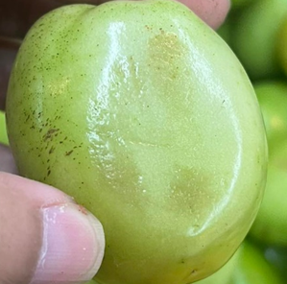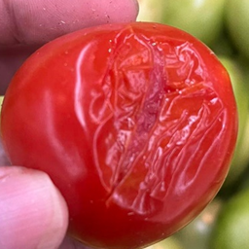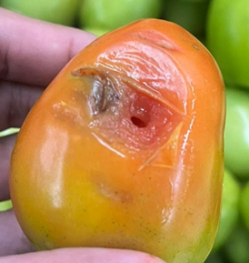

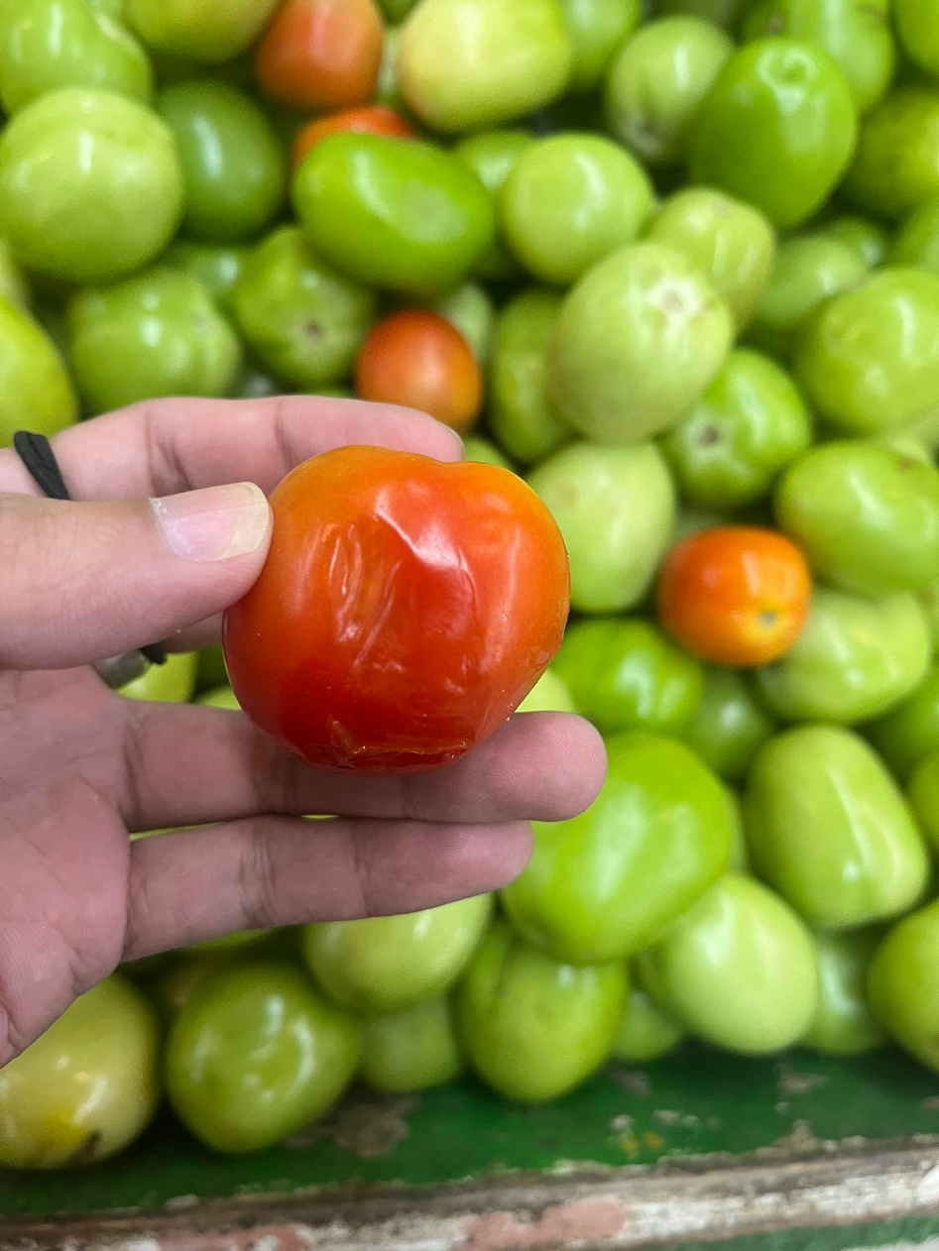

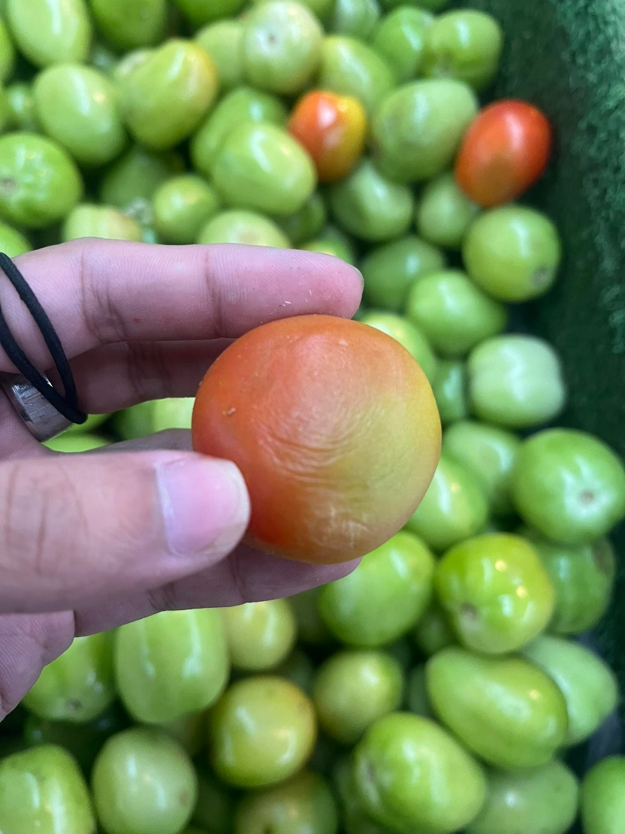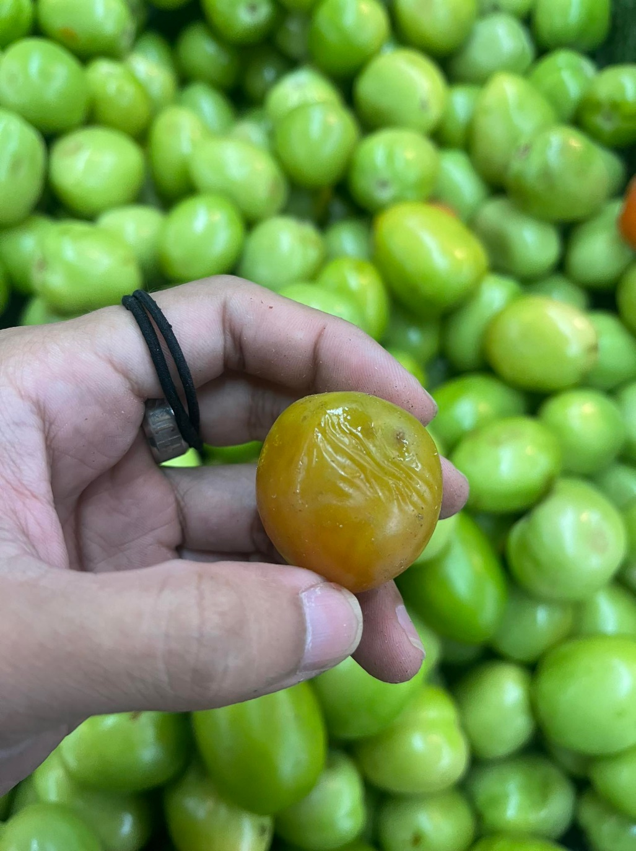

**Appendix C: User Interface**

Conveyor

Detection section equipped with cameras, where tomatoes will be detected.

Slidind door

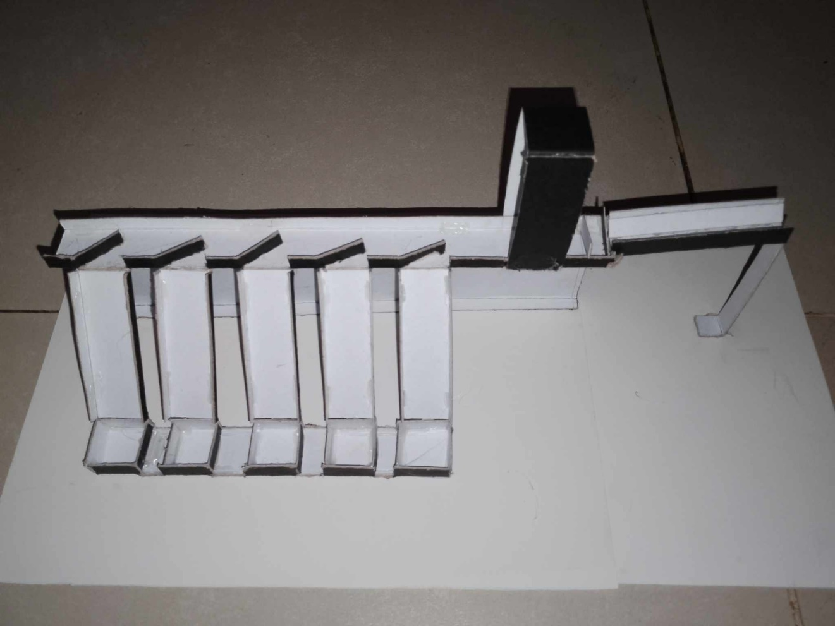

Container equipped with sensor and led ligth

Small green tomato

Large green tomato

Small red tomato

Large red tomato

Bad tomato

Tunnel (Funnel type)

Slidind door (alternate up and down door)

Pathway

**Appendix D: Test Cases**

|  |  |  |  |
| --- | --- | --- | --- |
| **Test Scenario ID** | Put harvested tomatoes into the tunnel | **Test Case ID** | Put harvested tomates |
| **Test Case Description** | Tomatoes will be lined on the tunnel | **Test Priority** | High |
| **Pre-Requisite** | Tomatoes should be present | **Post-Requisite** | Successfully lined the tomatoes |

|  |  |  |
| --- | --- | --- |
| **Steps No.** | **Action** | **Expected Output** |
| 1 | Farmers will place the harvested tomatoes on the tunnel | Tomatoes have been effectively arranged and positioned within the tunnel |
| 2 | The first sliding door will open, allowing for the passage of a tomato | Tomato successfully passed through the first door |
| 3 | The second sliding door will open, allowing the tomato that has already passed through the first sliding door to proceed through the second door as well | Tomato successfully passed through the second doorway |

|  |  |  |  |
| --- | --- | --- | --- |
| **Test Scenario ID** | Detecting tomatoes by size, color and quality | **Test Case ID** | Detecting tomatoes |
|  |  |  |  |
| **Test Case Description** | Tomatoes will be detected by predefined criteria | **Test Priority** | High |
| **Pre-Requisite** | Only one tomato present | **Post-Requisite** | Successfully detected the tomato |

|  |  |  |
| --- | --- | --- |
| **Steps No.** | **Action** | **Expected Output** |
| 1 | The conveyor system will transport the tomato to the section designated for camera detection | Successfully transported the tomato to the camera section |
| 2 | The camera will accurately identify tomatoes | Tomatoes successfully identified |

|  |  |  |  |
| --- | --- | --- | --- |
| **Test Scenario ID** | The tomatoes will be sorted accordingly and placed into their appropriate containers | **Test Case ID** | Tomato sorting |
|  |  |  |  |
| **Test Case Description** | Tomatoes will be sorted | **Test Priority** | High |
| **Pre-Requisite** | Only one tomato present | **Post-Requisite** | Successfully sort tomatoes |

|  |  |  |
| --- | --- | --- |
| **Steps No.** | **Action** | **Expected Output** |
| 1 | If the tomato is identified as bad tomato, the corresponding sliding door designated for such tomato will open, allowing the detected tomato to be safely placed into its designated container. | Successfully placed the bad tomato within its designated container |
| 2 | If the tomato is identified as being both red and large, the corresponding sliding door designated for such tomato will open, allowing the tomato to be placed into its appropriate container. | Successfully placed the large red tomato within its designated container |
| 3 | If the tomato is identified as being both red and small, the corresponding sliding door designated for such tomato will open, allowing the tomato to be placed into its appropriate container. | Successfully placed the small red tomato within its designated container |
| 4 | If the tomato is identified as being both green and large, the corresponding sliding door designated for such tomato will open, allowing the tomato to be placed into its appropriate container. | Successfully placed the large green tomato within its designated container |
| 5 | If the tomato is identified as being both green and small, the corresponding sliding door designated for such tomato will open, allowing the tomato to be placed into its appropriate container. | Successfully placed the small green tomato within its designated container |
| 6 | If the tomato identified does not meet the predetermined criteria, the conveyor will proceed to transport the tomato to the final segment of its path, where it will then be deposited into its designated container | Successfully transferred the excess tomato into its designated container |

**Appendix E: Evaluation Tool**

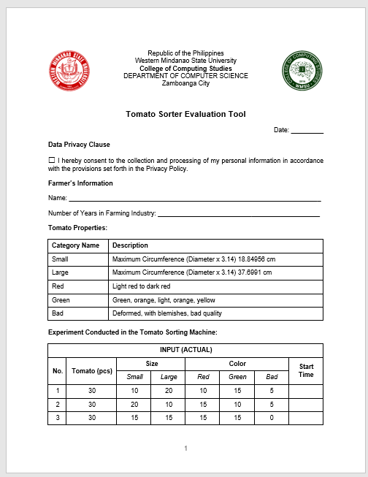

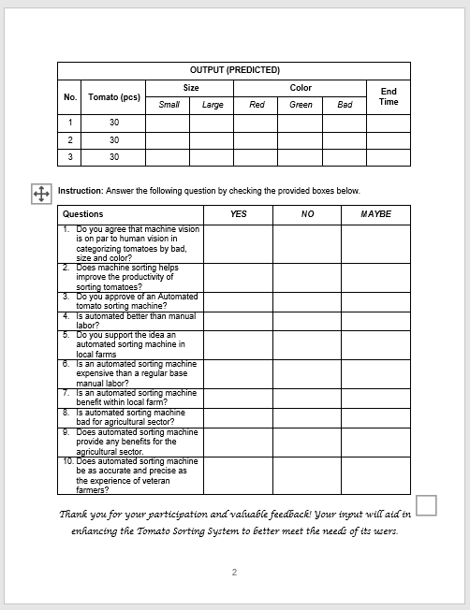

**Appendix F: Relevant Source Code**

**Appendix G: User Manual**

**Appendix H: Plagiarism Report**

**Appendix I: Research Critique and Editing Certificate**

**Appendix J: Curriculum Vitae**

Note: 1 page per researcher